**Essential Logistics KPIs and Metrics Part 2**

These 18 logistics metrics can help your business manage costs and improve customer satisfaction. These costs relate to shipping, distribution, transportation, warehousing and logistics performance. Use these KPIs to identify problems and optimize your processes.

**Formulas for Warehouse and Order Management KPIs**

* **Unplanned Shipment:** The unplanned shipment, also known as the unplanned supply order lines, are the number of supply order lines not being shipped soon. The company has no plans to ship these products. This metric is the number of unplanned shipments compared to the total number of shipments.

**Unplanned Shipment Example:** Four unplanned shipments this month; 4,000 shipments completed this month

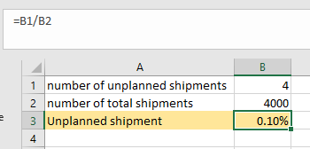

In this example, this company has 0.1% of its shipments in unplanned shipment status.

* **Order Accuracy:** Order accuracy, also known as order picking accuracy, is the number of orders picked and verified as accurate compared to the total number of orders picked for a period. This metric helps with process improvement in the warehouse.

**Order Accuracy Example:** Quality control verified 123 orders correct from the 128 picked today.

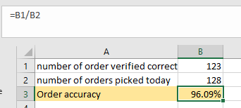

In this scenario, quality control staff verified that 96% of today's picks as accurate. Since this metric affects customer satisfaction, companies should work to make it as high as possible.

* **Inventory Accuracy:** The inventory accuracy KPI is the accuracy of inventory in stock compared to what the database shows are in stock. This metrics shows the effectiveness of your bookkeeping methods and ensures there are no stockouts.

**Inventory Accuracy Example:** There are 3,458 items counted in stock; the system lists 3,506 items.

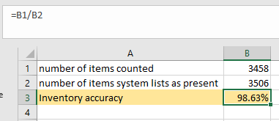

This example shows that 98.63% of items are accurately in-stock. The metric does not differentiate between entities, just the number of overall items.

* **Dock-to-Stock:** Dock-to-stock cycle time is how long it takes for a product to go from the start of its receipt to when it is put away and ready for sale compared to the total number of shipments received. Staff usually count this in hours.

**Dock-to-Stock Example:** 12 hours and 18 shipments

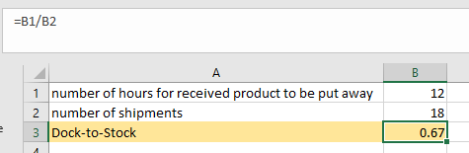

The equation shows that the dock-to-stock cycle time for this company is 0.67 hours per shipment.

* **Units Processed per Square Meter:** Units processed per square foot, also known as productivity in transferred volume, are distribution metrics that compare the number of units or goods processed to usable warehouse space.

**Units Processed per Square Meter Example:** 60,000 units and 16,400 square meters of usable area.

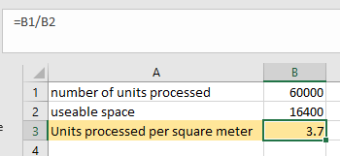.7 units/ft2

In this situation, there are 3.7 units/meter2, taking up a fair amount of usable warehouse space.

* **Space Use in Warehouse:** Space use in warehouse, also known as space utilization, is the percent of bins used. This metric ensures optimal use of warehouse space. Calculate this metric by comparing the amount of warehouse space used by what is available.

**Space Use in Warehouse Example:** 3,300 square meter used in a 16,500- square meter warehouse

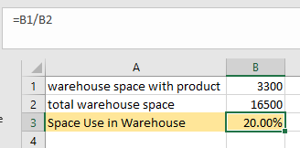

In this example, 20% of the warehouse space is filled with product, which is average for warehouses.

**Formulas for Logistics Performance Metrics**

* **Cost per Kilo:** Cost per pound is the cost of a shipment compared to its weight in kilos. Use this measure to compare carriers, weekly invoices and individual shipments.

**Cost per Kilo Example:** P836.24 for a shipment of 2,200 kilos.

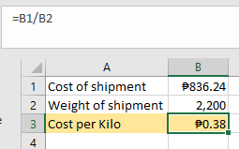

In this situation, the cost per kilo is P0.38.

**Cost per Kilometer:** Cost per mile calculates the profit distribution for a load. Marketing also uses this metric for campaigns. However, in distribution, the measurement is the total monthly expenses or total load cost compared to the number of miles driven. The prices are fixed and variable.

**Cost per Kilometer Example:** P2,540 variable costs, P2,312 fixed costs and 100 monthly kilometers

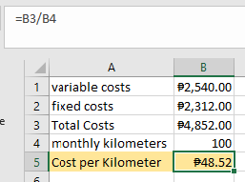

In this example, if the mileage stays at 100 km per month, spending P48.52 per km will meet expenses.

In this scenario, we broke down the loads by region and product. For example, 120 shipments of four different products, totaling 26,342 items, went to the eastern region last month.

**KPI Do's**

* Prioritize processes and operations.
* Make your KPIs relevant.
* Choose simple, attainable KPIs. Simple measures lead to targeted fixes.
* Consider the performance elements of your chosen metrics.
* Focus on the activities that help staff perform better.

**KPI Don'ts**

* Do not make up new standards. Learn about your industry KPIs and focus on them first.
* Do not develop measures without getting buy-in from staff.
* Do not make your KPIs intangible. Regularly review them and make adjustments.
* Do not make your KPIs static. Raise the benchmarks once you meet or exceed them.
* Do not shoot for merely meeting minimums for all KPIs. Instead, strive to reach the minimum acceptable performance levels.